Software Requirements Specification

for

PASAKAY: An Online Land Vehicle Pooling and Rental Services with GPS Technology

**Version 1.0 approved**

**Prepared by Paul Vincent R. Arellano, Aila Mei S. Atienza and Enrico Rosano Jr. R.**

**Team A.R.A**

**July 8, 2021**

**Table of Contents**

**Table of Contents ii**

**Revision History ii**

**1. Introduction 1**

1.1 Purpose 1

1.2 Document Conventions 1

1.3 Intended Audience and Reading Suggestions 1

1.4 Project Scope 1

1.5 References 1

**2. Overall Description 2**

2.1 Product Perspective 2

2.2 Product Features 2

2.3 User Classes and Characteristics 2

2.4 Operating Environment 2

2.5 Design and Implementation Constraints 2

2.6 User Documentation 2

2.7 Assumptions and Dependencies 3

**3. System Features 3**

3.1 System Feature 1 3

3.2 System Feature 2 (and so on) 4

**4. External Interface Requirements 4**

4.1 User Interfaces 4

4.2 Hardware Interfaces 4

4.3 Software Interfaces 4

4.4 Communications Interfaces 4

**5. Other Nonfunctional Requirements 5**

5.1 Performance Requirements 5

5.2 Safety Requirements 5

5.3 Security Requirements 5

5.4 Software Quality Attributes 5

**6. Other Requirements 5**

**Appendix A: Glossary 5**

**Appendix B: Analysis Models 6**

**Appendix C: Issues List 6**

**Revision History**

|  |  |  |  |
| --- | --- | --- | --- |
| **Name** | **Date** | **Reason For Changes** | **Version** |
| Enrico R Rosano Jr | 07/08/21 |  |  |
| Aila Mei S. Atienza | 07/08/21 |  |  |
| Paul Vincent R. Arellano | 07/08/21 |  |  |

# Introduction

## Purpose

PASAKAY: An Online Land Vehicle Pooling and Rental Services with GPS Technology is a platform that provides better transport services that involves integrated technologies to facilitate the system. From manual activities in vehicle pooling and rental services, this includes GPS navigation and SMS notification.

The project aims to alter traditional methods in acquiring vehicles for ride-sharing and rental services of transport. This would be a great benefit for both users such as riders or passengers and the driver or the owner to attain quality services to reduce consumptions of manual work though in a much more efficient way.

## Document Conventions

When writing SRS documents for Online Vehicle Pooling and Rental Services we used best font style and size, headings are bold to make it more readable.

## Intended Audience and Reading Suggestions

This project is a prototype for vehicle pooling and rental system and it is restricted within the college premises. This has been implemented under the guidance of college professors. This project is useful for the team as well as the users. This document is written for the researchers, project managers, programmers, designers, developers, testers, documentation writers, users involved in vehicle pooling and rental services that consists of the various steps and procedures for the pooling and rental. The following section describes the rest of the system function. Scope and other overall description. Finally, with the references.

## Project Scope

PASAKAY is a mobile application operated by riders (passengers) and driver or vehicle owner, which will be the primary users. Administrators are responsible for maintaining data, generating reports, adding, searching and deleting records as well as viewing and monitoring the entire operation. Both users and administrators can access the rental and booking services such as prices, category (shared or not), search filter, location tracker (nearby vehicle and driver), and estimated time of arrival (pick up). Drivers will receive updates from admin about the schedule, location, and passengers to pick-up. It also includes features such as SMS notification (reservation details) and cancellation. Updates such as confirmation of bookings and rental via SMS will be sent immediately after the user completes the registration and login process, to inform the passengers about the reservations that have been made by the specified time. In addition, riders can interact with administrators via phone in some circumstances, such as malicious behavior and will be able to view and share experiences and ratings, the systems can support payment and lastly, only administrators can access user data and generated reports such as income and expenses reports. Nasugbu Municipality residents intend the system for use.

**References**

<https://www.coursehero.com/file/p355itf/12-Document-Conventions-When-writing-then-SRS-document-for-Atlantic-Lottery/>

<https://www.britannica.com/technology/Windows-OS>

<https://searchoracle.techtarget.com/definition/MySQL>

<https://www.twilio.com/docs/glossary/what-is-sms-api-short-messaging-service>

# Overall Description

## Product Perspective

## Advancements in technology have an enormous contribution to the growth of shared on-demand mobility. Travelers using the traditional method have a hard time finding an available vehicle nearby or at the exact location. Furthermore, commuters are unaware of how many seats are still available for occupancy or how many passengers could fill them. Nasugbu Batangas, considered as one with a growing population and a continuous number of people and vehicle usage, could result in congestion and pollution by daily users of personal vehicles. The fundamental reason why the researchers propose an innovative vehicle pooling and rental services application with GPS technology integration, is to reduce the physical efforts expended by passengers in finding private vehicles for rental and bookings. As a response to the existing system, the proponents provide Android-based applications with advanced facilities to support the comfort and ease of travel of passengers. To establish transparency between users and drivers, the application provides vehicle owner/driver-specific details as well as vehicle information. The system can track and locate the location of a nearby vehicle for a reservation using GPS. It also includes SMS notifications for booking and rental confirmation, and other important details for more secure and safe travel. Vehicle pooling is one of the methods to resolve issues but also to offer flexibility for the users. The researchers intend to integrate advanced facilities for the users and drivers to adapt in a new system for a better and efficient way of vehicle pooling and rental but also to have a safe and secure journey. The integration of the advanced application could help passengers, vehicle owners as well as the business to save time, energy, and costs. In addition, the application is user-friendly and can be environment-friendly as it also resolves the community problems such as congestion, pollution, parking spaces, and the stress of driving.

## Amidst pandemic, the system can be also useful as it offers private vehicles that are open for rental services. This technology could help travelers to avoid crowded areas and reduce physical activities by having face-to-face interaction with other people.

## 

## Product Features

The major features of Pasakay: An Online Land Vehicle Pooling and Rental Services with GPS Technology as shown in below entity–relationship model (ER model)

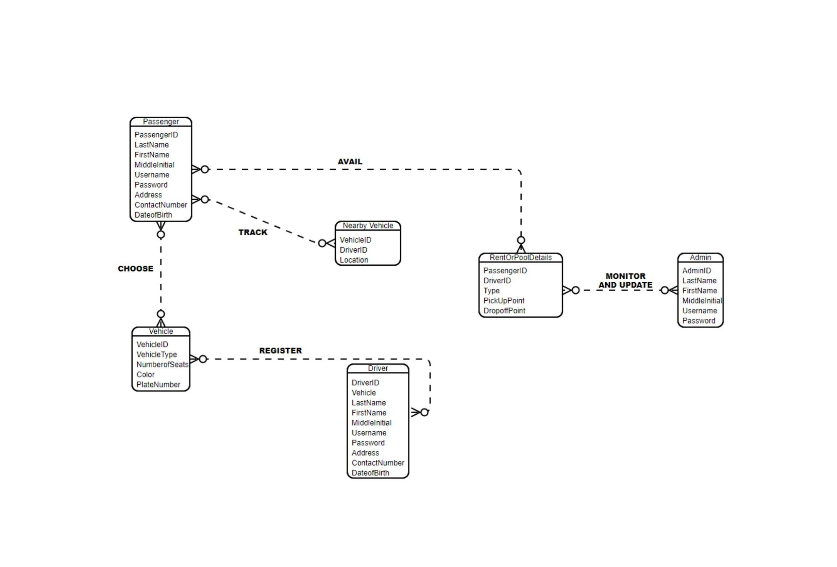

The diagram shows the layout of Pasakay: An Online Land Vehicle Pooling and Rental Services with GPS Technology – entity–relationship model

## User Classes and Characteristics

## There are three types of users: the passengers, administrator and drivers.

## Passengers: These will be the users that will be using the app to find the nearest vehicle in the area to take a ride.

## Administrator: Administrator as the operator of the system who’s responsible for the up-keep data; generating reports, adding and deleting records, viewing and monitoring for the whole operation.

## Drivers: The vehicle owner or driver in the proposed system is the one who receives updates from the administrators and also receives the schedule, location and the passenger who will be pick-up.

## The most important users of this system will be the administrator. They have the ability to add and remove vehicle owners or drivers that receive the schedule, location and the passenger who will be pick-up.

## Operating Environment

* The only hardware needed is the android phone and the laptop or computer.
* OS: Windows

We choose the Windows operating system because it is applicable to everyone and it’s easy to use.

* Database: MySQL

We chose the MySql database because it’s easy to use and we have used it before.

* Phone OS: Jelly Bean up to Pie

We choose this phone operating system because it is the operating system that android phones are using nowadays.

## Design and Implementation Constraints

## SQL commands for above queries/applications

## How the response for application 1 and 2 will be generated. Assuming these are global queries. Explain how various fragments will be combined to do so.

## User Documentation

## The system is user-friendly and created in such a way that the user with little or no knowledge of the can use this therefore no user manual will be required.

* A FAQ document available publicly on the application should be sufficient to answer any questions users have.

## Assumptions and Dependencies

## User interface and some functionalities can change during the development process of a project. And also new functionalities can be added which are able to change the dependent system requirements.

## 3. System Features

The system features of Pasakay: An Online Land Vehicle Pooling and Rental Services with GPS Technology as shown in below:

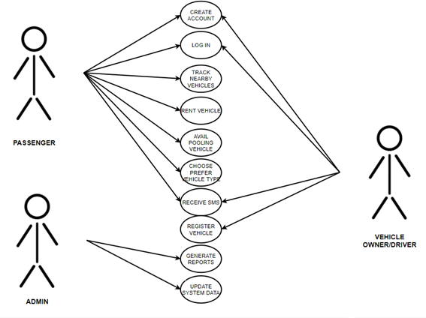

The diagram shows the layout of Pasakay: An Online Land Vehicle Pooling and Rental Services with GPS Technology – Use Case diagram.

## 3.1 Home Page

*<Don’t really say “System Feature 1.” State the feature name in just a few words.>*

3.1.1 Description and Priority

The of Pasakay: An Online Land Vehicle Pooling and Rental Services with GPS Technology maintains information on tracking vehicle, number of seats, payment, drivers rating and rental services. This project is high priority because it would a lot to the commuters and drivers. Priority 9.

3.1.2 Stimulus/Response Sequences

The user can reserve bookings and rental services, while the vehicle owner can receive updates or notification by operator and passenger. Users who interact with the application should fill the forms for the validation process. Account profiles will be displayed; modules for location are also provided such as the location of the traveler and where to drop. It includes a google map for mapping locations to find the available vehicles to reserve. The application will tell the passengers the searched nearby available vehicles and drivers. Mode preferences are also included containing all types of vehicles is available in the area such as car van etc., after the booking procedure, the dialog box will appear notifying the person that the reservation is successful. Lastly, text messages will be received by the passenger for important details needed for the reservation.

3.1.3 Functional Requirements

The user will be able to register for the bookings and rental services where they can sign up, and recover forgot password. The application includes two types of user the passenger and vehicle owner or the driver. This are the mainly actors who will interact with the application. Passengers can reserve bookings and rental modules; they can also rate the drivers. Actions and function is based on the buttons that designed on the application.

REQ-1: Create account and Login, the commuters and drivers will create an account to be able to use the system,

REQ-2: Track nearby vehicle, the commuters will be able to see nearby vehicle available.

REQ-3: SMS verification, after the commuters find nearby vehicle and rent, the system will verification that you already rent.

# 4. External Interface Requirements

## 4.1 User Interfaces

* The passenger will see the interface for renting a vehicle or avail pooling on the android application. The vehicle owner or the driver will see the driver’s interface that notify them if a passenger will rent or avail vehicle pooling. The administrator will see the web system interface to manage all the transactions of the application.

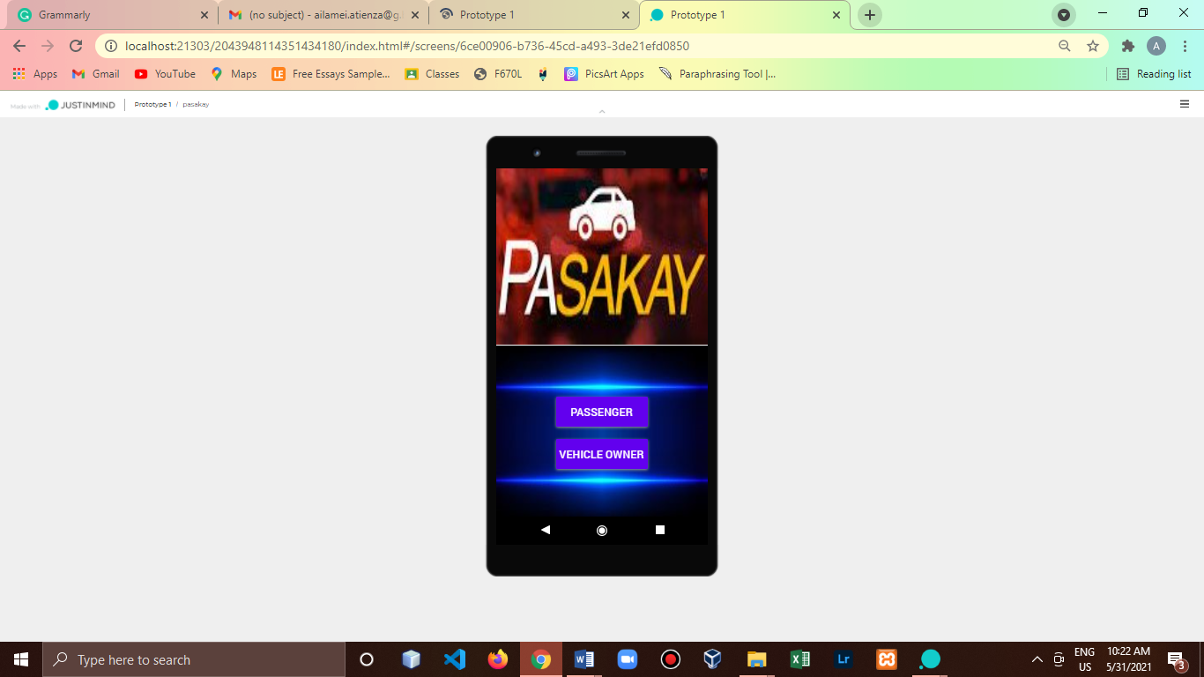 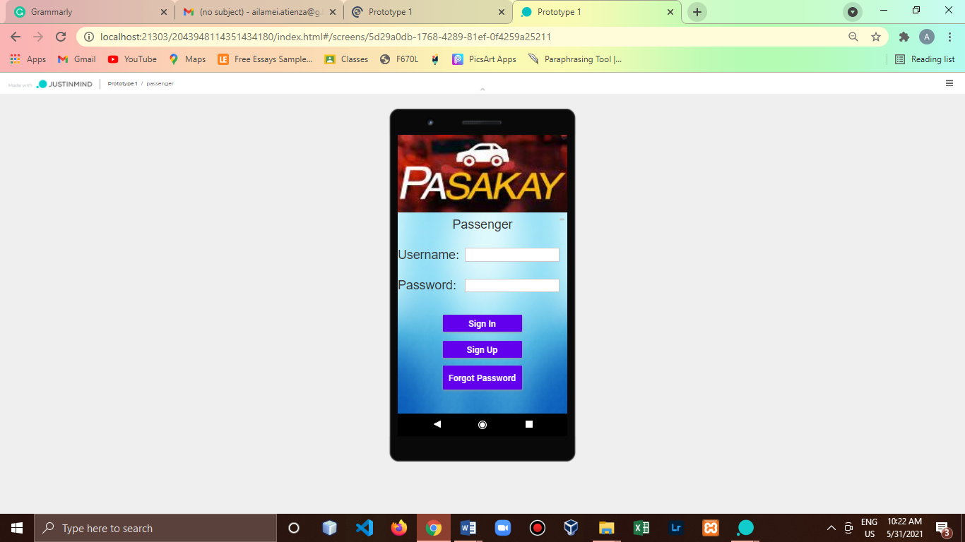 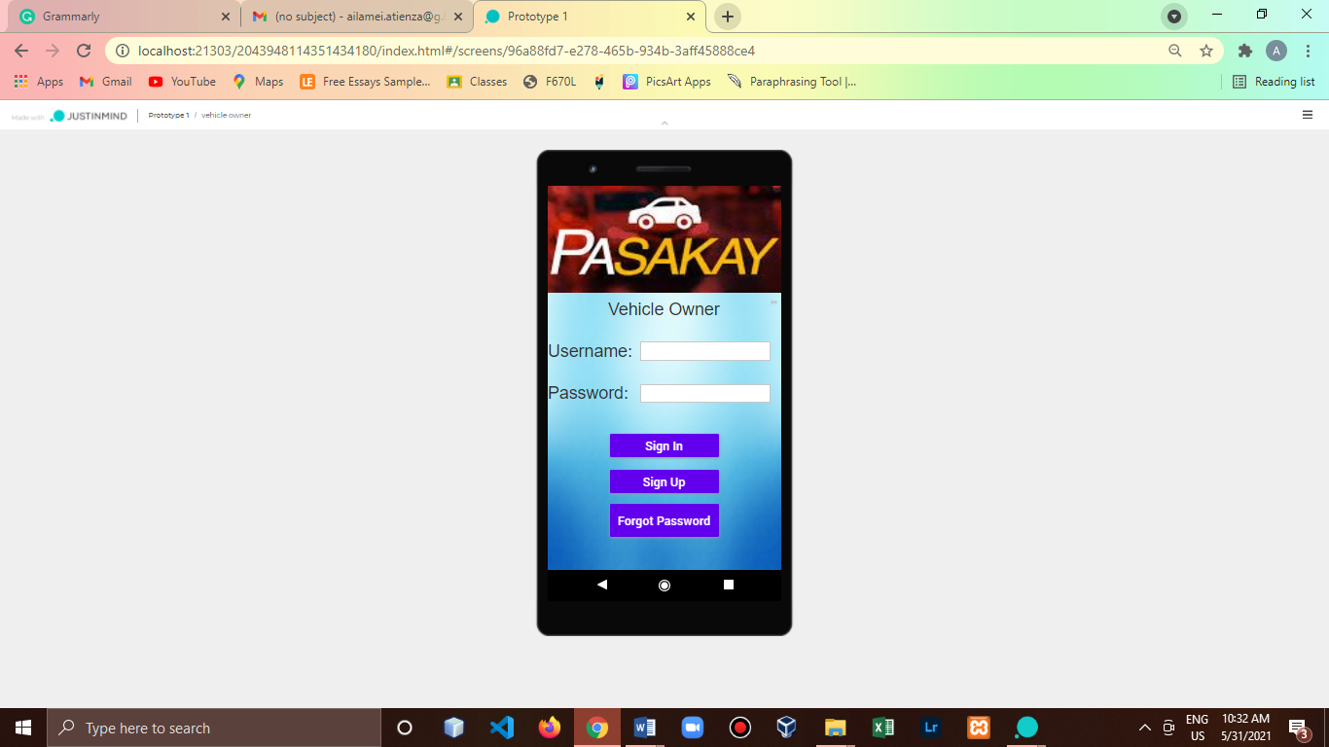

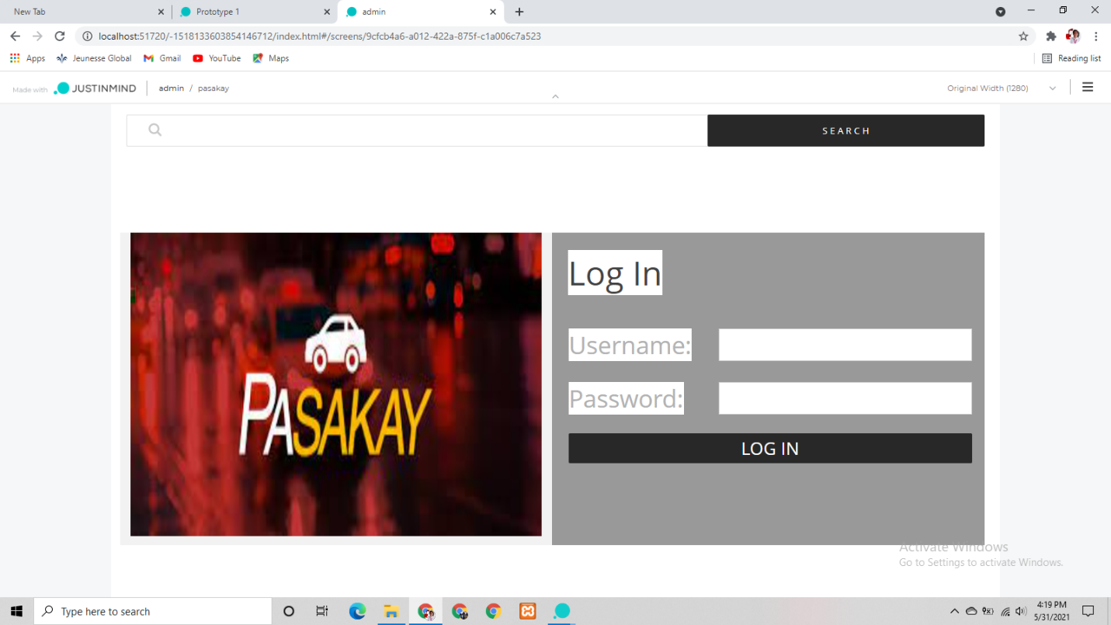

* After being logged in with their correct corresponding emails and passwords, they will be directed to their profile to do various activities.

## 4.2 Hardware Interfaces

* The only hardware needed is the android phone and the laptop or computer.
* The system will use the standard hardware and software resources.

## 4.3 Software Interfaces

**OS:** Windows

We choose the Windows operating system because it is applicable to everyone and it’s easy to use.

**Database:** MySQL

We chose the MySql database because it’s easy to use and we have used it before.

**Phone OS: Jelly Bean up to Pie**

We choose this phone operating system because it is the operating system that android phones are using nowadays.

**4.4 Communications Interfaces**

* The system uses the SMS Api for communication interfaces to send updates to the users for the services. The system also uses the SMS Api as a means of communication for recovering forgotten accounts.
* The application will communicate with the database that will hold all the data that will enter the system.

# 5. Other Nonfunctional Requirements

## 5.1 Performance Requirements

*<If there are performance requirements for the product under various circumstances, state them here and explain their rationale, to help the developers understand the intent and make suitable design choices. Specify the timing relationships for real time systems. Make such requirements as specific as possible. You may need to state performance requirements for individual functional requirements or features.>*

## 5.2 Safety Requirements

* If there are possible loss of accounts of the user we provided a way to recover their accounts through sending one time password to their registered mobile number.
* If there is data that is personal that comes out to the public there is an agreement that is stated before registering an account, like the terms and conditions.

## 5.3 Security Requirements

* For security requirements of the system, on creating an account of the user there is a need for ID verification to verify if all of the information of the user is valid.
* For the passenger verification there is a need to verify their accounts through valid ID, while the vehicle owner needs their Driver’s License and the Registration of the car.

## 5.4 Software Quality Attributes

* **Availability:** The system is available everyday with the specified dates and times and specified places.
* **Correctness:** The passenger should be picked up by the driver from the pick-up point and should reach the passengers target destination.
* **Maintainability:** The administrator should update all the data to maintain the correct schedule and availability of the systems performance.
* **Usability:** The system should satisfy the passenger and drivers expected needs.

# 6. Other Requirements

*<Define any other requirements not covered elsewhere in the SRS. This might include database requirements, internationalization requirements, legal requirements, reuse objectives for the project, and so on. Add any new sections that are pertinent to the project.>*

**Appendix A: Glossary**

*<Define all the terms necessary to properly interpret the SRS, including acronyms and abbreviations. You may wish to build a separate glossary that spans multiple projects or the entire organization, and just include terms specific to a single project in each SRS.>*

*SMS API - A SMS API is a well-defined software interface which enables code to send short messages via a SMS Gateway. As the infrastructures for SMS communications and the internet are mostly divided, SMS APIs are often used to 'bridge the gap' between telecommunications carrier networks and the wider web. SMS APIs are used to allow web applications to easily send and receive text messages through logic written for standard web frameworks.*

*MySQL - MySQL was originally developed to handle large databases quickly. Although MySQL is typically installed on only one machine, it is able to send the database to multiple locations, as users are able to access it via different MySQL client interfaces. These interfaces send SQL statements to the server and then display the results.*

*Windows - Microsoft Windows, also called Windows and Windows OS, computer operating system (OS) developed by Microsoft Corporation to run personal computers (PCs). Featuring the first graphical user interface (GUI) for IBM-compatible PCs, the Windows OS soon dominated the PC market. Approximately 90 percent of PCs run some version of Windows.*

**Appendix B: Analysis Models**

Entity Relationship Diagram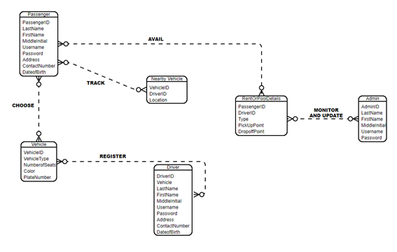

Data Flow Diagram

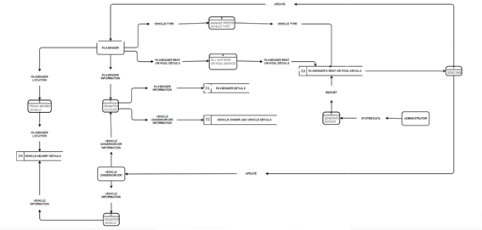

Use Case Diagram



**Appendix C: Issues List**

* Integration Issues
* Communication Breakdown
* Mismanage timeline
* Feature Overload
* Feature Creep